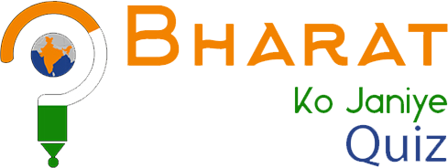
Ministry of External Affairs
Government of India
(Overseas Indian Affairs-II Division)

High Commission of India Participate and get chance to visitIndia






BHARATKOJANIYEQUIZ2020-21
(Know India Quiz Contest 2020-21)
Eligibility:
Bharat Ko Janiye Quiz is open for 3 categories of participants - PIO, NRI & Foreigners between 18 to 35 years.
Registrations starts from: 30th September 2020
For registration & participation, please visit: www.bharatkojaniye.in
Brief Guidelines:
There will be four rounds of quiz in online mode.
1st round - Welcome round open to everyone. Winners will get Gold, Silver and Bronze medals.
2nd round - Winners of 1st round participate.
3rd round - Top 10 contenders of second round participate- total 30 participants.
4th & Final round - Top 7 contenders of 3rd round will participate- total 21 participants.
Final winners - 5 in each category (3 medal winners and 2 consolation prizes). All 15 winners will be invited for India tour after Covid.



@OIA_MEA @OverseasIndianAffairs

